ECE 441 Fall 2021

WEEK #8 GROUP MEETING LOG

Lab Session: 2

Group Number: 2

Instructor: Dr. Jafar Saniie

Due Date: 03-09-2022

Acknowledgment: I acknowledge all of the work (including figures and codes) belongs to me and/or persons who are referenced.

Member 1: Alan Palayil

Member 2: Fabian Garcia

Member 3: Gabriel Gutierrez

[Smart Mirror - *Through the Speculum*]

**Project Goal:**

* Create an interactive smart mirror with gesture control, voice commands, and possibly facial recognition.
* Include accessories like LED strips and a sound system.
* Design a compacted design for the 24inch display

**Standards used in Project:**

Not applicable during this stage of the project

**System Constraints:**

* Xbox Kinect is meant for windows/microsoft devices; however, some additional libraries can be installed to the raspberry pi to help run this device.
* There is currently no operational wake engine for alexa voice services

**Prior Knowledge Acquired Critical to Design Project:**

ECE 100, ECE 211, ECE 213, ECE 218, ECE 242, ECE 307, ECE 308, ECE 311, ECE 319, ECE 407, ECE 411, ECE 436, ECE 438, ECE 485, CS 115, CS 116, CS 330, CS 331, CS 350, CS 351, CS 450

Note:

CS 331- Data Structures and Algorithms (Python Programming)

ECE 411: Power Electronics

Meeting 1

| Date | 3/5/2022 |
| --- | --- |
| Start Time | 12:00 PM |
| Duration | 1 hour |
| Attendance | All attended |

1. **Agenda**

Discuss research

**Gabriel:**

[All-seeing PI photobooth](https://www.raspberrypi.com/news/all-seeing-pi-photo-booth/)

Hardware required: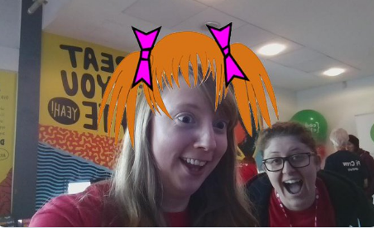

* Raspberry PI
* 2 buttons for breadboard
* 4 Male-female jumper leads (standard breadboard cables)
* Camera module

Software libraries required:

* GUIzero
* twython

An issue that might arise is the program use of a camera module; however since the team is using an Xbox Kinect camera, we’ll have to do some more research in case the module is still needed. If this program can not be successfully run using the Kinect then an extra module will be added.

This open-source program was last updated in March 2017 so it probably is no longer compatible with the most recent version of Raspbian.

1. **Tasks**

| **1 - Idea development** | | |
| --- | --- | --- |
| **Task** | **Assigned to** | **Due Date** |
| OpenCV | Everyone | 3/12 |
| Research on Workout APIs | Everyone | 3/12 |
| Photobooth Research | Everyone | Complete |
| Test All seeing Pi photobooth | Gabriel | 3/19 |
| Look into the Magic mirror issue | Alan | 3/7 |

1. **Work Distribution**

| **Alan Palayil** | Work on the issue that took place on the magic mirror and work on the bluetooth integration of the speaker. |
| --- | --- |
| **Fabian Garcia** | Will work on OpenCV. Didn’t have time to work on implementation |
| **Gabriel Gutierrez** | Reached more into the photo booth library |

1. **Progress and Milestones**

We have received some of our components for our project. We have made sure the materials function straight out of the box and we will be waiting for the remaining parts to come in.

1. **Next Steps**

For this week the team has shifted their focus to their other course midterms so most of the allotted work will be research-oriented.

Next meeting: 3/7/2022

Meeting 2

| Date | 3/7/2022 |
| --- | --- |
| Start Time | 1:00 PM |
| Duration | 1:30 hour |
| Attendance | All attended |

1. **Agenda**

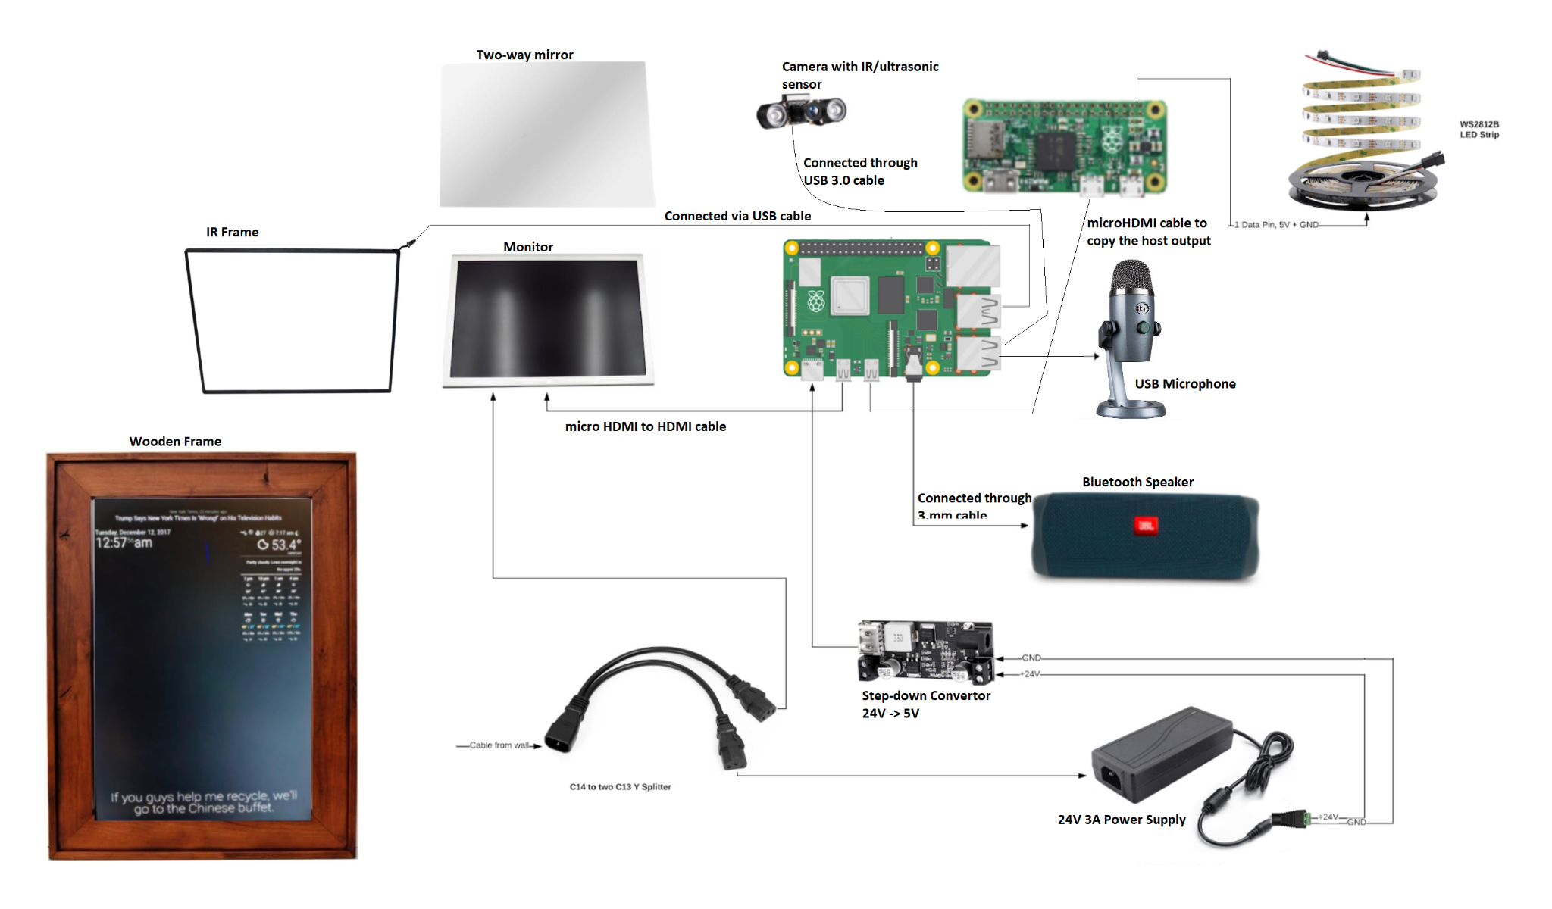

The team has received the following components:

1. Speaker
2. LEDs
3. Power extension cords
4. 2-Way acrylic mirror
5. Monitor
6. Step down convert
7. Microphone
8. Power supply

The team can begin testing the microphone and speaker with the magic mirror software and google voice services.

Things to consider:

-The monitor the team received is a 16:10 rather than a 16:9, This shouldn't be an issue for the IR frame since the resolution of the monitor can be adjusted to have black bars at the top and bottom

-The team will find out a design so the Bluetooth speaker buttons can be accessed easily. 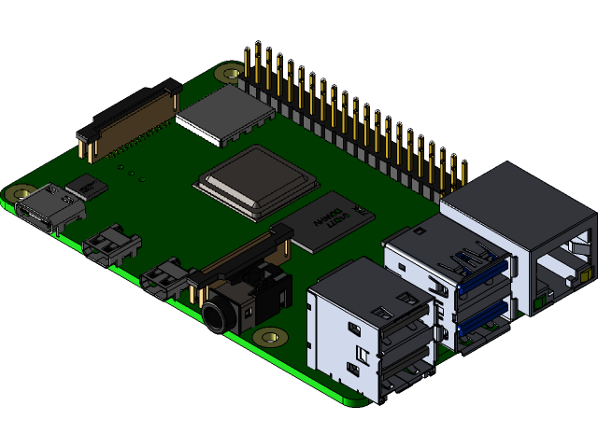

To help with the design choice, a 3D model will be made interlocking all out components and devices. Fusion 360 is an Autodesk software that allows multiple users to work on the same 3D model together.

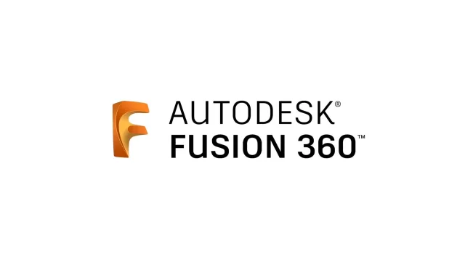

Alan: Magic mirror module is working again after a temporary issue.

1. **Tasks**

| **1 - Idea development** | | |
| --- | --- | --- |
| **Task** | **Assigned to** | **Due Date** |
| OpenCV | Everyone | 3/12 |
| Research on Workout APIs | Everyone | 3/12 |
| Test All seeing Pi photobooth | Gabriel | 3/19 |
| 3D model project | Gabriel |  |
| Look into the Magic mirror issue | Alan | Completed |

1. **Work Distribution**

| **Alan Palayil** | Will look into photobooth filters and workout mirrors. |
| --- | --- |
| **Fabian Garcia** | Will continue working on OpenCV and looking into possible workout methods using the Kinect |
| **Gabriel Gutierrez** | Found a viable way to 3D model the smart mirror design. |

1. **Progress and Milestones**

The speaker has been disassembled. This will allow us to more feasibly incorporate it into our design,

1. **Next Steps**

The majority of the initial work will be completed during Spring break after midterm week is over. This will give us plenty of time to test and debug any of the programs we try to implement. We will be waiting for the XBox Kinect, as it is our main focus for the project. Once we acquire the hardware, we can further test OpenCV on it and see if it functions as we intend. Apart from waiting for the Kinect, we are still waiting on the IR frame so we can work on specific aspects of the project